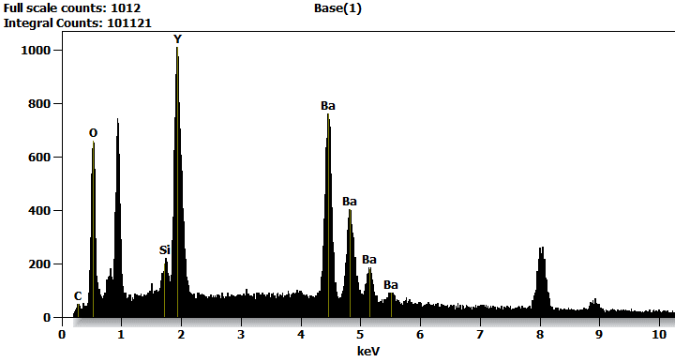

Live Time: 49.2 sec.

Acc.Voltage: 15.0 kV Take Off Angle: 20.4 deg.

Quantitative Results for: Base(1)

|  |  |  |  |
| --- | --- | --- | --- |
| ***Element*** | ***Net***  ***Counts*** | ***Weight %*** | ***Atom %*** |
| ***C*** | 345 | 1.02 | 5.02 |
| ***O*** | 4556 | 13.29 | 49.27 |
| ***Si*** | 816 | 1.12 | 2.37 |
| ***Si*** | 0 | --- | --- |
| ***Y*** | 0 | --- | --- |
| ***Y*** | 14840 | 28.98 | 19.33 |
| ***Y*** | 0 | --- | --- |
| ***Ba*** | 16920 | 55.59 | 24.00 |
| ***Ba*** | 0 | --- | --- |
| ***Total*** |  | 100.00 | 100.00 |

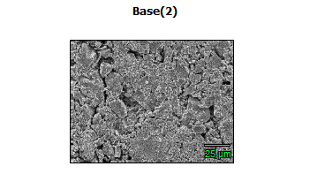

Data Type: Counts

Image Resolution: 512 by 384

Image Pixel Size: 0.32 µm

Map Resolution: 256 by 192

Map Pixel Size: 0.64 µm

Acc. Voltage: 15.0 kV

Magnification: 1000

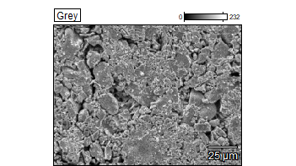 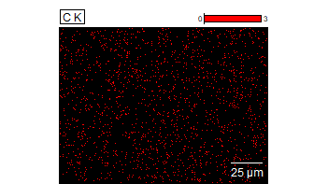

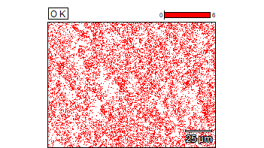 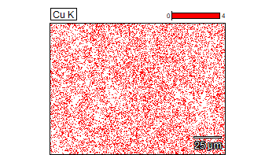

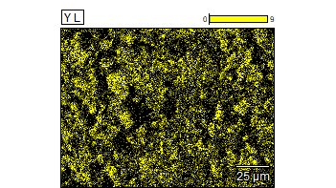 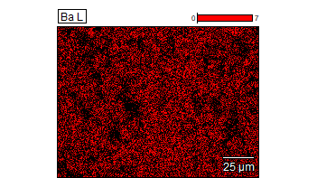



Data Type: Counts

Image Resolution: 512 by 384

Image Pixel Size: 0.32 µm

Map Resolution: 256 by 192

Map Pixel Size: 0.64 µm

Acc. Voltage: 15.0 kV

Magnification: 1000

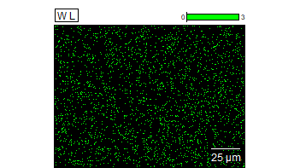

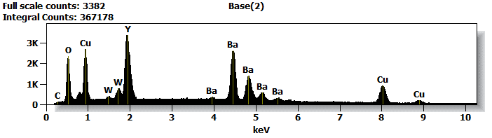

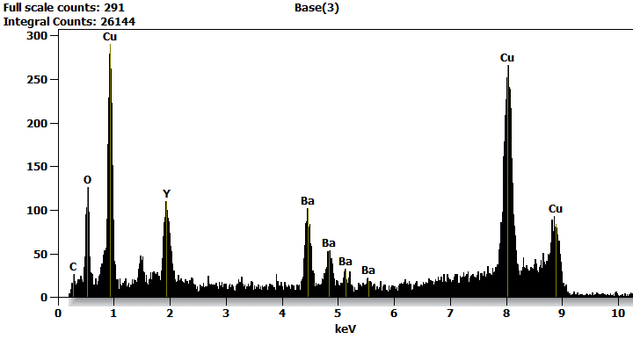

Live Time: 297.5 sec.

Acc.Voltage: 15.0 kV Take Off Angle: 19.5 deg.

Quantitative Results for: Base(3)

|  |  |  |  |
| --- | --- | --- | --- |
| ***Element*** | ***Net***  ***Counts*** | ***Weight %*** | ***Atom %*** |
| ***C*** | 102 | 0.85 | 4.25 |
| ***O*** | 647 | 3.42 | 12.91 |
| ***Cu*** | 4602 | 76.85 | 72.94 |
| ***Cu*** | 2632 | --- | --- |
| ***Y*** | 2 | --- | --- |
| ***Y*** | 1392 | 6.72 | 4.56 |
| ***Y*** | 0 | --- | --- |
| ***Ba*** | 1869 | 12.16 | 5.34 |
| ***Ba*** | 0 | --- | --- |
| ***Total*** |  | 100.00 | 100.00 |

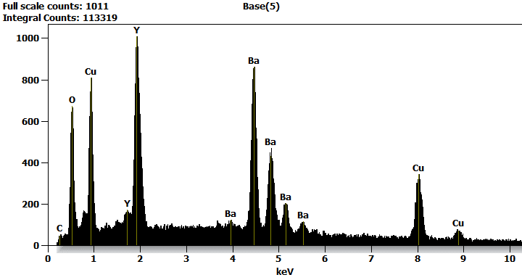

Live Time: 229.3 sec.

Acc.Voltage: 15.0 kV Take Off Angle: 19.5 deg.

Quantitative Results for: Base(5)

|  |  |  |  |
| --- | --- | --- | --- |
| ***Element*** | ***Net***  ***Counts*** | ***Weight %*** | ***Atom %*** |
| ***C*** | 319 | 0.71 | 3.81 |
| ***O*** | 4329 | 8.23 | 33.04 |
| ***Cu*** | 5112 | 28.06 | 28.37 |
| ***Cu*** | 6852 | --- | --- |
| ***Y*** | 0 | --- | --- |
| ***Y*** | 14595 | 20.84 | 15.06 |
| ***Y*** | 0 | --- | --- |
| ***Ba*** | 19476 | 42.16 | 19.72 |
| ***Ba*** | 0 | --- | --- |
| ***Total*** |  | 100.00 | 100.00 |

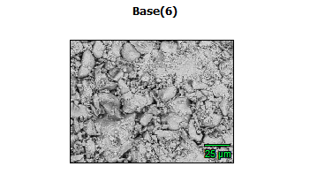

Data Type: Counts

Image Resolution: 512 by 384

Image Pixel Size: 0.32 µm

Map Resolution: 256 by 192

Map Pixel Size: 0.64 µm

Acc. Voltage: 15.0 kV

Magnification: 1000

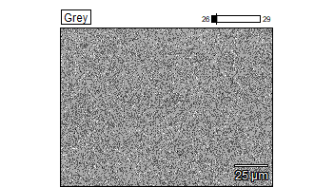 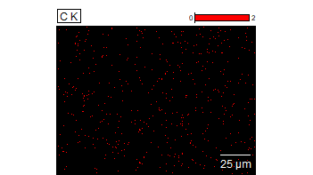

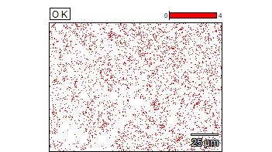 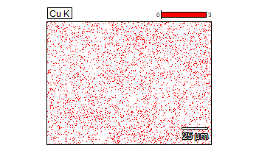

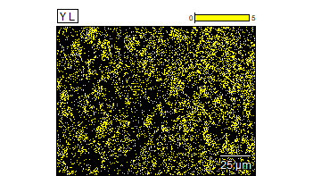 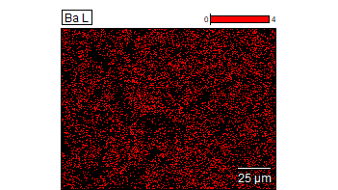



Data Type: Counts

Image Resolution: 512 by 384

Image Pixel Size: 0.32 µm

Map Resolution: 256 by 192

Map Pixel Size: 0.64 µm

Acc. Voltage: 15.0 kV

Magnification: 1000

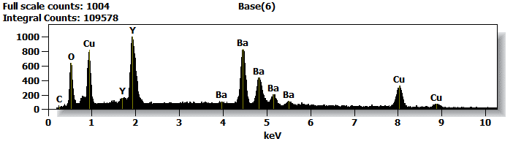

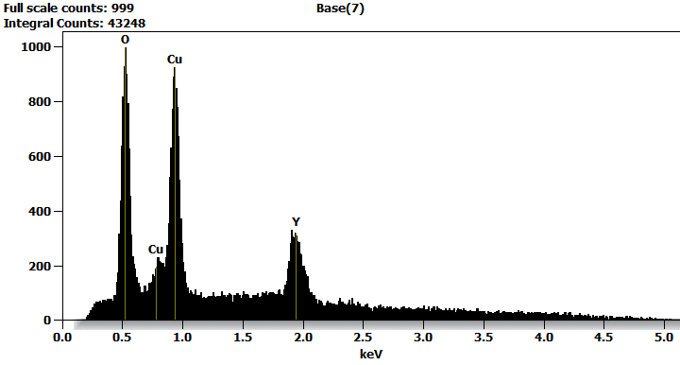

Live Time: 364.7 sec.

Acc.Voltage: 5.0 kV Take Off Angle: 18.6 deg.

Quantitative Results for: Base(7)

|  |  |  |  |
| --- | --- | --- | --- |
| ***Element*** | ***Net***  ***Counts*** | ***Weight %*** | ***Atom %*** |
| ***O*** | 6359 | 18.63 | 51.11 |
| ***Cu*** | 7483 | 44.22 | 30.55 |
| ***Y*** | 4025 | 37.15 | 18.34 |
| ***Y*** | 0 | --- | --- |
| ***Total*** |  | 100.00 | 100.00 |

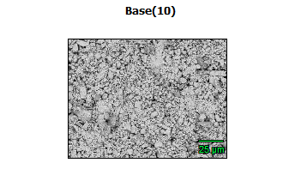

Data Type: Counts

Image Resolution: 512 by 384

Image Pixel Size: 0.32 µm

Map Resolution: 256 by 192

Map Pixel Size: 0.64 µm

Acc. Voltage: 5.0 kV

Magnification: 1000

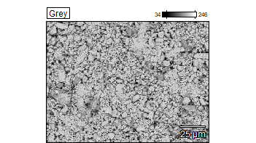 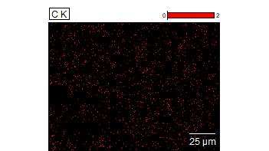

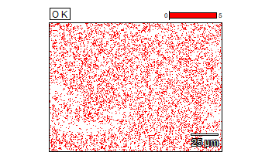 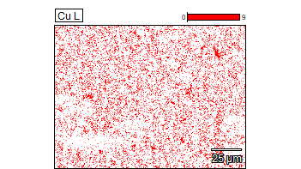

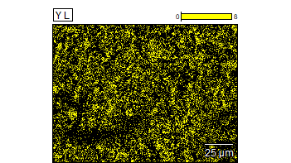 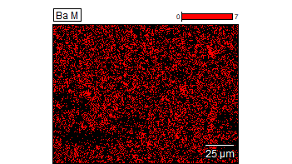



Data Type: Counts

Image Resolution: 512 by 384

Image Pixel Size: 0.32 µm

Map Resolution: 256 by 192

Map Pixel Size: 0.64 µm

Acc. Voltage: 5.0 kV

Magnification: 1000

